Default

📌 Definition:
# Source: AI Source: Provided by: [Data Path: Persons Table -> ID Column: 1, Name_En Column: Motasem Essam] -> From: [Chatgpt (GPT‑5 Mini)] on [12/9/2025]
Default (no keyword) access means that a variable or method is accessible only within the same package. If no access modifier is specified, Java applies default access automatically.

🧠 Simple idea:
# Source: AI Source: Provided by: [Data Path: Persons Table -> ID Column: 1, Name_En Column: Motasem Essam] -> From: [Chatgpt (GPT‑5 Mini)] on [12/9/2025]
Default = “Accessible inside the same package” 📦

🔍 Key characteristics:
# Source: AI Source: Provided by: [Data Path: Persons Table -> ID Column: 1, Name_En Column: Motasem Essam] -> From: [Chatgpt (GPT‑5 Mini)] on [12/9/2025]
- 📦 No keyword is used (no public, private, or protected)
- 🔗 Accessible within the same package only
- ❌ Not accessible from outside the package
- 🧩 Helps organize related classes together

📌 Example (Java):
# Source: AI Source: Provided by: [Data Path: Persons Table -> ID Column: 1, Name_En Column: Motasem Essam] -> From: [Chatgpt (GPT‑5 Mini)] on [12/9/2025]
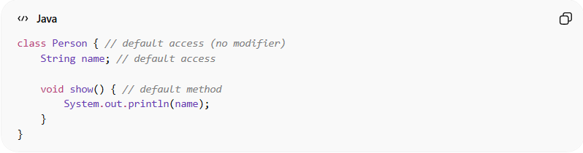
class Person { // default access (no modifier)
String name; // default access

void show() { // default method
System.out.println(name);
}
}

Another class in the same package:
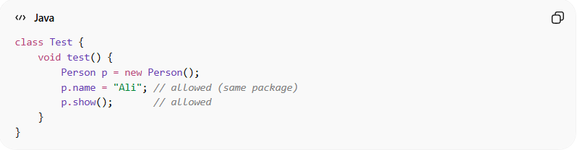
class Test {
void test() {
Person p = new Person();
p.name = "Ali"; // allowed (same package)
p.show(); // allowed
}
}

❌ From a different package:
# Source: AI Source: Provided by: [Data Path: Persons Table -> ID Column: 1, Name_En Column: Motasem Essam] -> From: [Chatgpt (GPT‑5 Mini)] on [12/9/2025]
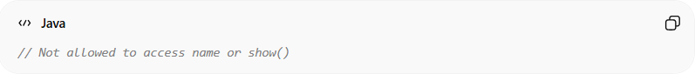
// Not allowed to access name or show()

🔄 Access summary:
# Source: AI Source: Provided by: [Data Path: Persons Table -> ID Column: 1, Name_En Column: Motasem Essam] -> From: [Chatgpt (GPT‑5 Mini)] on [12/9/2025]
Access Level | Same Class | Same Package | Subclass | Other Packages
Default | ✔️ | ✔️ | ❌ | ❌

🎯 Why default access is important:
# Source: AI Source: Provided by: [Data Path: Persons Table -> ID Column: 1, Name_En Column: Motasem Essam] -> From: [Chatgpt (GPT‑5 Mini)] on [12/9/2025]
- 📦 Groups related classes together
- 🧩 Simplifies internal package communication
- 🔄 Provides limited protection without being too strict
- ⚙️ Useful for internal system design

🎯 Summary:
# Source: AI Source: Provided by: [Data Path: Persons Table -> ID Column: 1, Name_En Column: Motasem Essam] -> From: [Chatgpt (GPT‑5 Mini)] on [12/9/2025]
Default access allows members to be accessible only within the same package, providing controlled and package-level visibility.

